Physics 11

Heat And CoolingTest

Answers to questions to be written in the space provided

Answers to questions involving calculations should be evaluated and given in decimal form.

Quote the final answer to not more than four significant figures.

Marks maybe deducted for not showing working.

Working must be legible and clearly set out.

Questions containing the instruction estimate may give insufficient numerical data for their solution. Students should provide appropriate figures to enable an approximate solution to be obtained.

Name __________________________

Teacher__________________

Mark__________

1. Consider a cup of coffee at 95oC and a bath of water at 40oC.  
   1. By considering the molecules of water, explain why the coffee is at a higher temperature?
   2. Which has the greater internal energy, the coffee or the bath of water? Explain.
2. The diagram below shows a reverse cycle air conditioner.

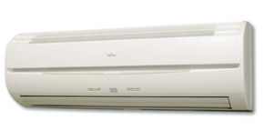

* 1. What does the term “reverse cycle” mean
  2. Explain how the air conditioner is able to cool a room?

1. Consider the following advertisement for an evaporative air cooler. Sketch a diagram of the internal structure of such a cooler and explain how it works from a particle point of view.

**4.** Complete the following conversions:

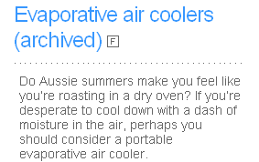

* 1. 25.0 oC to K
  2. 4.50 x 102 K to 0C

1. Consider the photo and diagram of a thermos flask shown below.  
     
     
     
     
   State the function of a vacuum flask and explain how it reduces heat transfer?

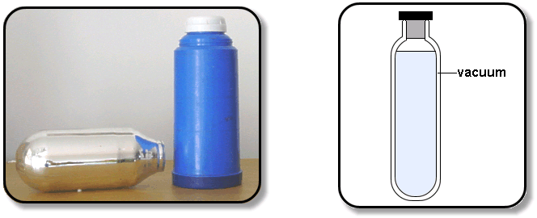

1. A website states that   
     
   “**Steam is hotter than boiling water, so take the lids off cooking liquids carefully to prevent steam burns.”**Is the steam hotter than the boiling water and why are burns from steam more dangerous than burns from boiling water?

**[12 marks]  
  
1.** In an experiment to measure the temperature of a Bunsen burner flame. A 250g piece of copper is held in the flame of a Bunsen burner for several minutes. The metal is then quickly transferred to 285 ml of water contained in a 40.0 g calorimeter at 288 K. Please note specific heat for Copper is 380Jkg-1K-1  
  
  
  
  
  
  
The water into which the metal has been placed is stirred until it reaches a steady temperature of 353 K.

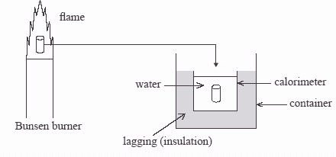

* 1. Explain why the metal is transferred as quickly as possible from the flame to the water.

**[2 mark]**

* 1. Explain why the water is stirred.  
      **[1 mark]**
  2. Assuming negligible energy losses in the processes involved, calculate the quantity of heat absorbed by the water and the calorimeter.  
      **[3 marks]**
  3. Using your answer from c) determine the temperature of the Bunsen flame.  
      **[3 marks]**
  4. If instead of water, the same mass of ethyl alcohol was used, by what factor would the temperature of this liquid change compared to the water? Show all working. Please note the specific heat for Ethyl Alcohol is 2400 Jkg-1K-1  
       
      **[3 marks]**

End of Test